HMR : Hot Module Replacement
It allows modules (like JavaScript, CSS, or other assets) to be updated in a live application without a full page reload
When you make changes to the source code, HMR will only replace the modified modules rather than reloading the entire page.
const App = () => {
return (
<div>
<Message/>
</div>
}

const Message = () => {
return (
<h1>
Welcome to React
</h1>
}
React create a virtual Dom of the components

Whenever any component is modified
Let say we modify the <h1> element of the Message component
const Message = () => {
return (
<h1>
Welcome to JavaScript
</h1>
}
React will check for the modified components(i.e dirty components)
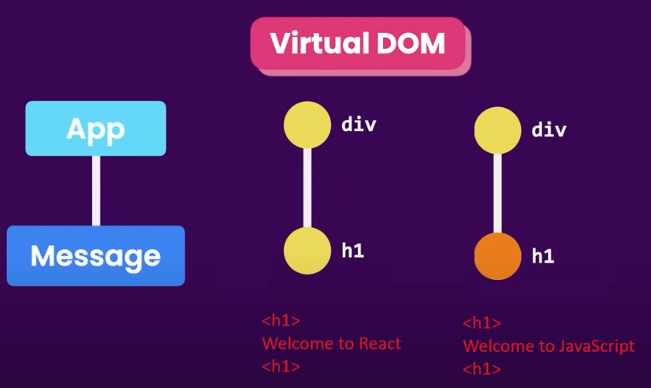
And modify the virtual Dom tree accordingly
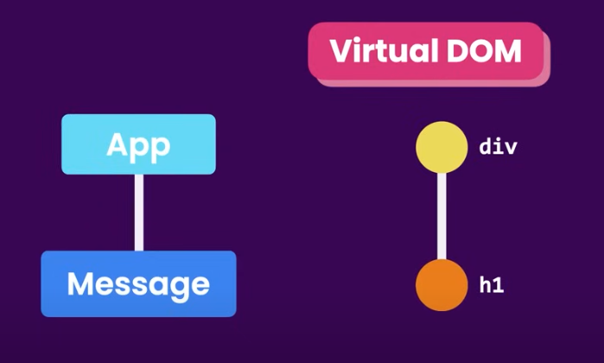
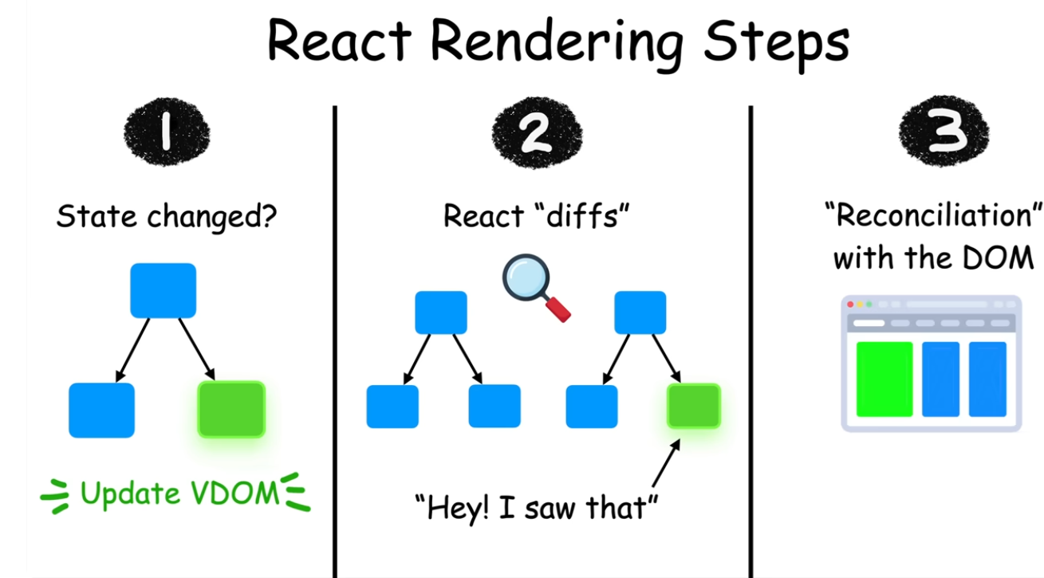

React uses a reconciliation algorithm to determine how to update the DOM when state or props change in a component. The goal is to make the process of updating the UI as efficient as possible, minimizing unnecessary re-renders and updates to the actual DOM.

import React, { useState } from "react";

function App() {
const [count, setCount] = useState(0);

const increment = () => setCount(count + 1);

return (
<div>
<h1>Counter: {count}</h1>
<button onClick={increment}>Increment</button>
</div>
);
}

export default App;

• Initially, React creates a Virtual DOM tree representing the UI structure (<div>, <h1>, <button>).
• When the state (count) is updated by clicking the button, React creates a new Virtual DOM.
• React compares the new Virtual DOM with the previous one and identifies that the only thing that changed was the value inside the <h1>.
• React efficiently updates the actual DOM to reflect this change in the UI without re-rendering the entire page.

